1. SE18

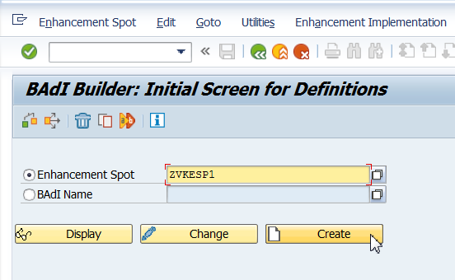

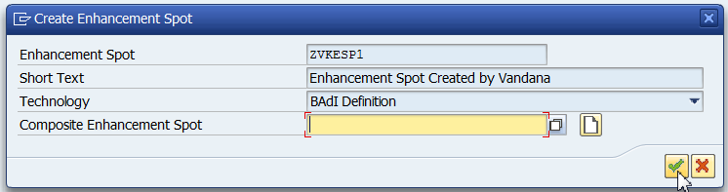

Save in package.

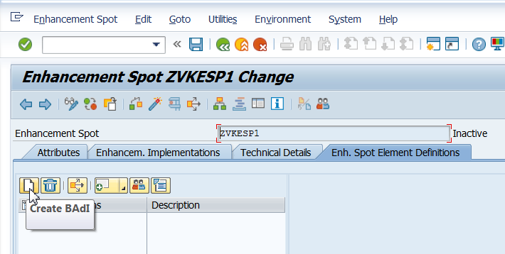

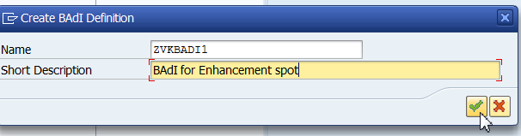

* Give the Interface name and create the Interface

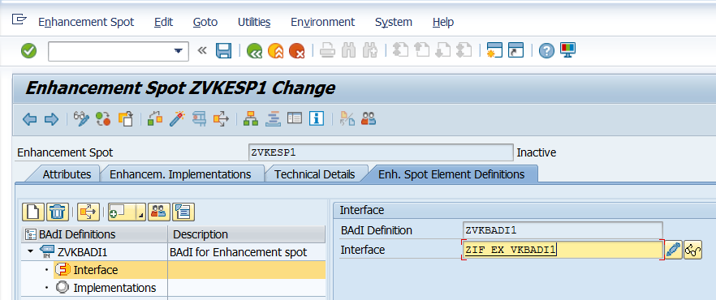

* Define the methods in the interface

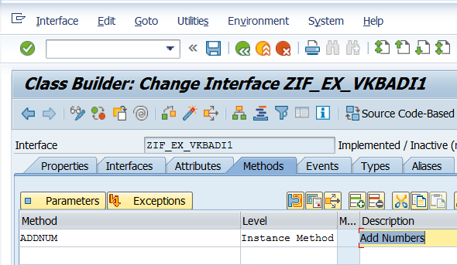

* Define Parameters for your method

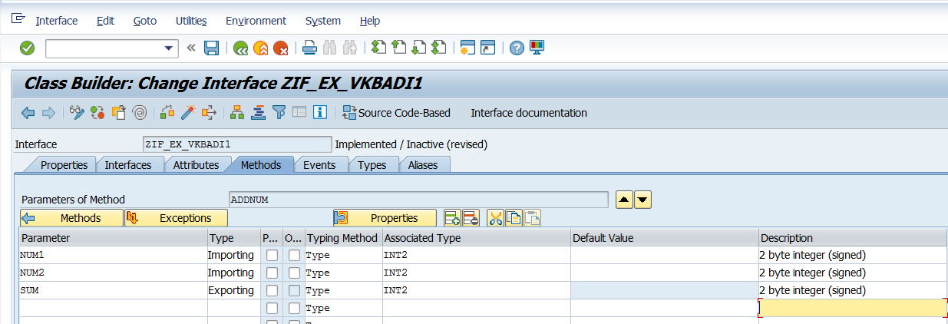

Save, Activate, Go Back.

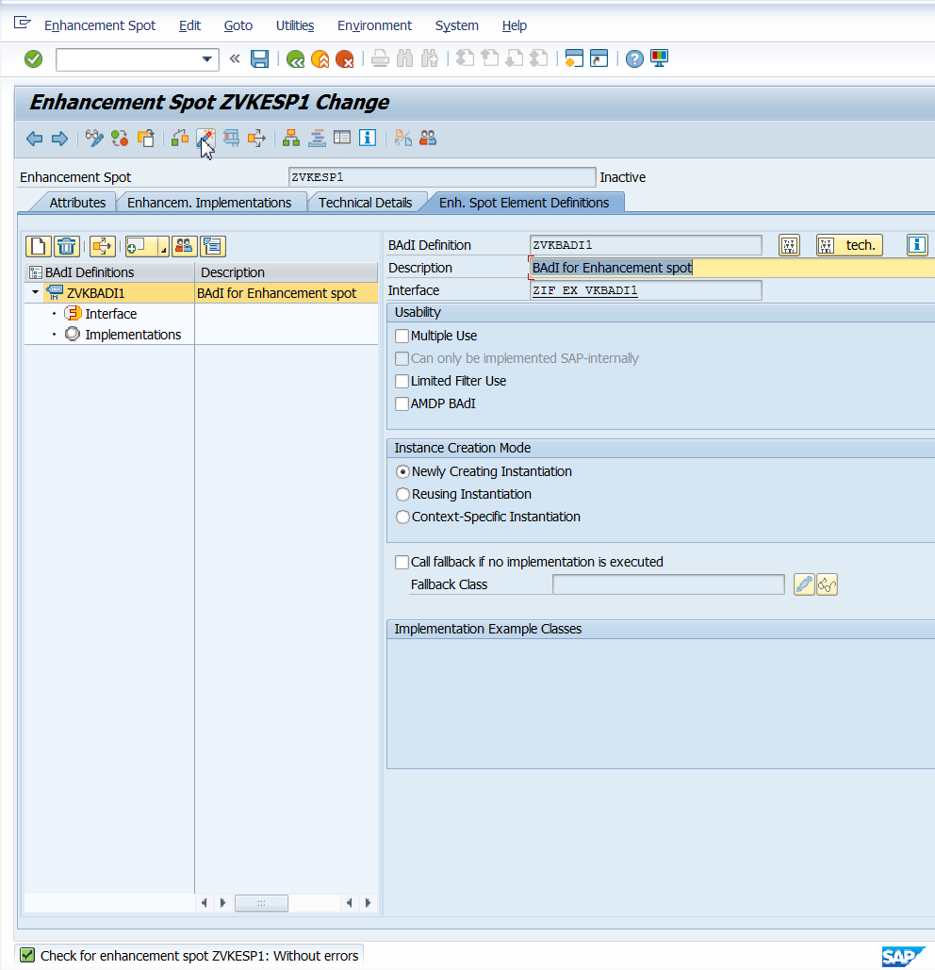

1. SE19

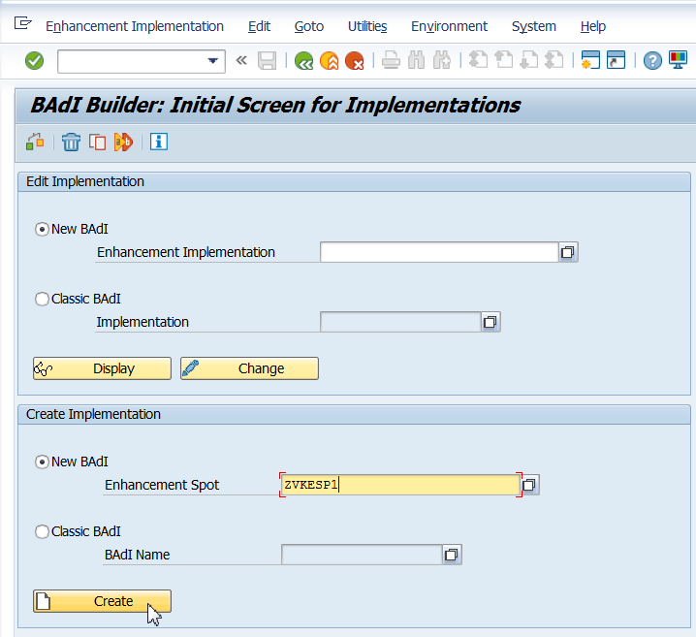

* Give Enhancement Spot Implementation name, short text and continue

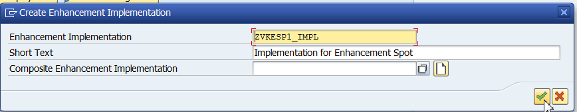

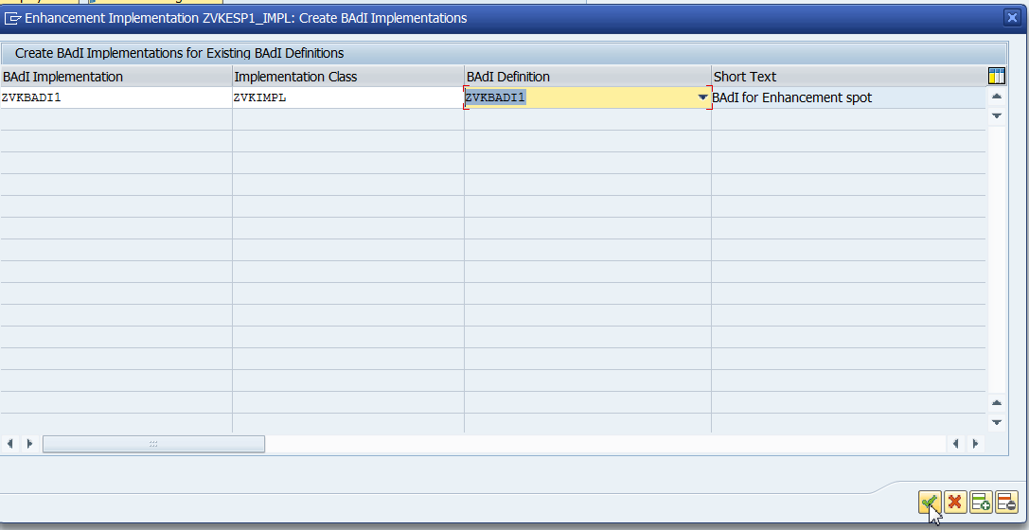

* Give the BADI Implementation Name, Implementation Class, BAdI Definition and continue

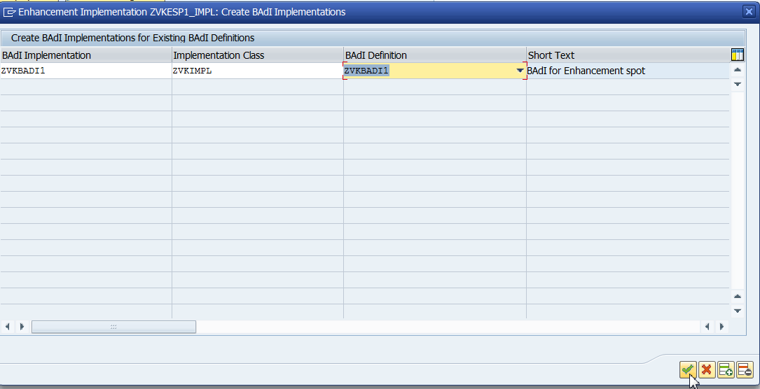

Double Click on Implementing Class.

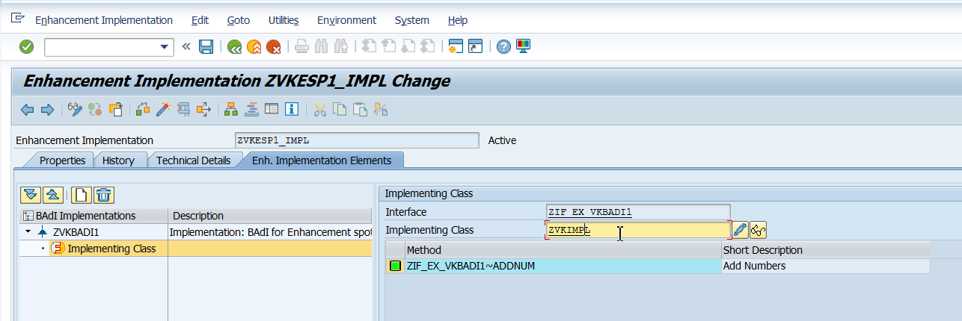

* Double click on the method to implement the method of the BAdI

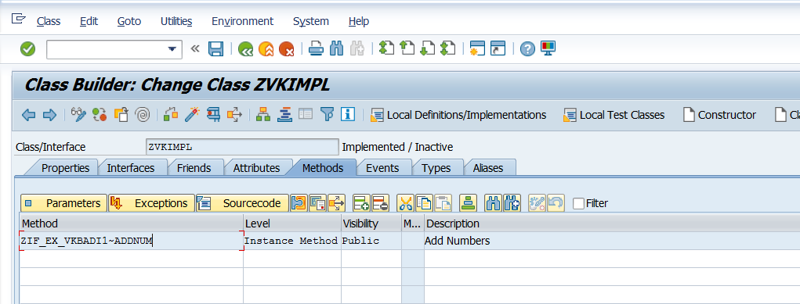

Save and activate.

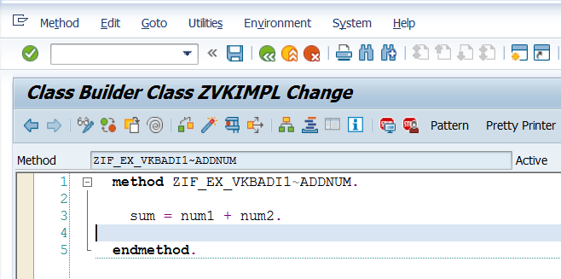

Call the above in SE38 program. See Text document(Create Enhancement Spot).

1. DSF
2. DF
3. FD
4. FDF